**SMART WASTE MANAGEMENT**

*A*

*Mini Project Report*

*Submitted in partial fulfilment of the Requirements for the award of the Degree of*

# BACHELOR OF ENGINEERING

IN

# INFORMATION TECHNOLOGY

By

#### VANSHIKA 1602-21-737-060

#### ANKITHA 1602-21-737-021

**SAI CHARAN 1602-21-737-306**



# Department of Information Technology Vasavi College of Engineering (Autonomous)

**ACCREDITED BY NAAC WITH 'A++' GRADE**

# (Affiliated to Osmania University and Approved by AICTE) Ibrahimbagh, Hyderabad-31

# 2023

# Vasavi College of Engineering (Autonomous)

**ACCREDITED BY NAAC WITH 'A++' GRADE**

# (Affiliated to Osmania University and Approved by AICTE) Hyderabad-500 031

**Department of Information Technology**



# DECLARATION BY THE CANDIDATE

#### We, VANSHIKA, ANKITHA, and SAI CHARAN bearing hall ticket numbers, 1602-21-737-060, 1602-21-737-021 and 1602-21-737-306 hereby declare that the project report entitled “SMART WASTE MANAGEMENT is submitted in partial fulfilment of the requirement for the award of the degree of Bachelor of Engineering in Information Technology.

This is a record of bonafide work carried out by us and the results embodied in this project report have not been submitted to any other university or institute for the award of any other degree or diploma.

**VANSHIKA**

**1602-21-737-060**

**ANKITHA**

**1602-21-737-021**

**SAI CHARAN**

**1602-21-737-306**

(Faculty In-Charge) (HeadDept of IT)

**ACKNOWLEDGMENT**

We extend our sincere thanks to Dr. S. V. Ramana, Principal, Vasavi College of Engineering for his encouragement.

We express our sincere gratitude to Dr. K. Ram Mohan Rao, Professor & Head, Department of Information Technology, Vasavi College of Engineering, for introducing the Mini-Project module in our curriculum, and for his suggestions, motivation, and co-operation for the successful completion of our Mini Project.

We also want to thank and convey our gratitude towards our mini project coordinators Ms.Hasseba Yaseen and S.Rajya Lakshmi, for guiding us in understanding the process of project development & giving us timely suggestions at every phase.

We would also like to thank the project reviewers for their valuable inputs and suggestions.

## Evaluation Process:

1. Continuous Internal Evaluation (CIE) – 30 marks :
   * Assesment-1 : [5 Marks]
     + Review of problem selection and Abstract.
   * Assesment-2: [10 Marks]
     + Review of project design and initial phase of implementation.
   * Assesment-3: [15 Marks]
     + Review of final implementation, presentation and report.

o

1. Semester End Examination (SEE) – 50 marks: Evaluation is done based on the following deliverables:
   * PowerPoint Presentation [10 Marks]
   * Demonstration of the application [20 Marks]
   * Project report [10 Marks]

Viva Voce [10 Marks]

**CONTENTS:**

**1.Abstract: 6**

**2.Introduction: 7**

**3.Technology: 8**

3.1:Software Requirements

3.2:Hardware Requirements

**4.Design: 9**

**5.Usecase Diagram: 10**

**6.Implementation: 11**

**7.Code: 31**

**8.Result: 35**

**9.Learning: 36**

**10.Conclusion: 37**

**ABSTRACT:**

Waste management is a multidimensional problem that requires technology, economics, and sociocultural and political activities to go hand in hand. At present, waste problem is still prevalent. The government is in continuous search for the solution of the raising waste management problem. One of the major factor that contributes to waste management problem is the behavior of the public or the waste producers in managing their own waste. A website which proposes selling and purchasing the desired waste

material. Design a project that will store the records properly and in organize manner using the database technology. Cost-effective web based system for the people to manage the overwhelming waste.

Creating different login/sign-in channels for sellers and purchasers in dashboard for easy access. The aim of the project is to design and develop a website system that will help in encouraging communities to participate in waste recycling activities, and provides an environmentally friendly, efficient and effective waste management system. Create an interface i.e. a website which proposes selling and purchasing of the desired waste materials and design a database that will store the records in an organized manner, using python language, html, css technologies.

**INTRODUCTION:**

As prosperity grows, 62 million tons of garbage is generated everyday by the 377 million people living in urban India, now the worlds third largest garbage generator. However, its not the amount of waste generated that’s as much of an issue as the fact that more than 45 million tons, or 3 million trucks worth of garbage is untreated.

Across India, existing systems for the collection, transportation and disposal of solid waste are mired in chaos. The problem is more acute in the urban areas, where rapidly growing populations generate increasingly larger quantities of solid waste that urban local bodies are unable to manage effectively.

This problem can be solved by active interaction of the public.Our project enhances the interaction and creates an awareness among the public about the efficient management of solid waste .This project involves active interaction compared with regular management system where waste is collected and isn’t recycled efficiently.

Through our project waste management process starts at the houses, waste can be categorized by the public at the ground level. The customer will separate the waste based on their recycling type and will sell that waste, so the complexity of managing waste will be reduced at the very first stage and with an active interaction of public.

**TECHNOLOGY:**

**SOFTWARE REQURIMENTS:**

* **HTML.**
* **CSS.**
* **JAVASCRIPT.**

**HARDWARE REQUIRMENTS:**

* **PERSONAL COMPUTER.**
* **MOBILE.**

**USECASE DIGRAM:**

**USECASE DESCRIPTION:**

**Actor: Admin and User.**

**Description: This feature creates an interface between the buyer and seller. This enhances the interaction and also breaks down the complexity levels in managing the waste.**

**Pre-conditions: Buyer and sellers need to create their individual Logins.**

**IMPLEMENTATION:**

**WASTE DISPOSAL:**

1. First waste generator has to create their profile, after creating the profile they should login

into their profile.

1. After that the user have to select the disposal tab an fill the form to dispose the waste.

**WASTE RECYCLE:**

1. The client first needs to register in the site . After the registration one can login into the site using their own profile.
2. After logging in the user can see the available waste and can select what kind he wants to purchase and for purchasing he needs to fill all the options.

**MODULE-WISE CODE:**

**HOME PAGE:**

**//home.html**

<home >

<link rel="stylesheet" href="home.css">

<h1 id="head">SMART WASTE MANGEMENT</h1>

<img src="https://i.pinimg.com/originals/e1/e2/4f/e1e24f24228256f020f1b8fd0706edb8.gif" id='selector'/>

<button onclick="document.location='idex.html'" display:inline id='size'>LOGIN</button>

</home>

**//home.css**

#head

{

position:absolute;

top:10%;

width: 100%;

max-width: 1500px;

text-align: center;

color:black;

font-size: 75px;

font-weight: 50px;

}

#selector

{

top:auto;

width:100%;

height:80%;

}

#size

{

position:center;

background-color:gray;

border:none;

color:white;

text-align:center;

font-size:20px;

display:inline-block;

padding:20px 32px;

}

**LOGIN PAGE:**

**//idex.html**

<div class="container">

<link rel="stylesheet" href="login.css">

<img>

<div>

<input type="text" autocomplete="off" id="name" placeholder="name">

<input type="email" autocomplete="off" id="email" placeholder="email">

<input type="password" autocomplete="off" id="password" placeholder="password">

<input type="text" autocomplete="off" id="Phone number" placeholder="Phone number">

<button class="submit-btn" onclick="document.location='webpage.html'">create account</button>

</div>

<a href="loginn.html" class="link">already have an account? Log in here</a>

</div>

**//loginn.html**

<div class="container">

<link rel="stylesheet" href="login.css">

<img>

<div>

<input type="text" autocomplete="off" id="email" placeholder="email">

<input type="password" autocomplete="off" id="password" placeholder="password">

<button class="submit-btn" onclick="document.location='webpage.html'">LOGIN</button>

</div>

</div>

**//login.css**

.logo{

height: 80px;

display: block;

margin: 0 auto 50px;

}

input[type="text"],

input[type="password"],

input[type="email"],

textarea{

display: block;

width: 300px;

height: 40px;

padding: 20px;

border-radius: 5px;

background: rgb(236, 213, 213);

border:black;

outline: none;

margin: 20px 0;

text-transform: capitalize;

color: #383838;

font-size: 14px;

box-shadow: 0 4px 10px rgba(0, 0, 0, 0.01);

font-family: 'roboto', sans-serif;

}

::placeholder{

color: #383838;}

.submit-btn{

width: 300px;

height: 40px;

text-align: center;

line-height: 40px;

background: #383838;

color: #fff;

border-radius: 2px;

text-transform: capitalize;

border: black;

cursor: pointer;

display: block;

margin: 30px 0;

}

label{

text-transform: capitalize;

display: inline-block;

margin-bottom: 10px;

font-size: 14px;

color: #383838;

}

label a{

color: #383838;}

.link{

color: #383838;

text-transform: capitalize;

text-align: center;

display: block;

}

**WEBPAGE:**

**//webpage.html**

<web>

<link rel="stylesheet" href="style.css">

<nav class="navbar">

<div class="nav">

<img src= "C:\Users\vansh\Downloads\WhatsApp Image 2023-01-29 at 5.14.06 PM (1).jpeg" class="brand-logo" alt="">

<div class="nav-items">

<div class="search">

<input type="text" class="search-box" placeholder="enter the type of waste">

<button class="search-btn">search</button>

</div>

</div>

<Li><A Href="home.html" Class="Under">Home</A></Li>

<Li><A Href="#" Class="Under">About Us</A></Li>

<Li><A Href="home.html" Class="Under">LogOut</A></Li>

</div>

</nav>

<ul class="links-container">

<li class="link-item"><a href="Ewaste.html" class="link">E-Waste</a></li>

<li class="link-item"><a href="Plastic.html" class="link">Plastics</a></li>

<li class="link-item"><a href="Glass And Fibres.html" class="link">Glass and fibres</a></li>

<li class="link-item"><a href="Organic waste.html" class="link">Organic Waste</a></li>

</ul>

<header class="hero-section">

<div class="content">

<img src="file:///C:/Users/vansh/OneDrive/Desktop/Waste-to-energy-gif.webp" class="logo" alt="">

<p class="sub-heading"></p>

</div>

</header>

<info class="info">

<h1>Advancing Zero Waste Solutions!!</h1>

<br><br><br>

<h2>WHO ARE WE AND WHAT DO WE DO?</h2>

<br>

</info>

<font class="font">

<br>

<p>India generates nearly 62 million tonnes of garbage each year and it is mainly by 377 million people living in urban<br>

India,now it is the world's 3rd largest garbage generator however nearly 31 million tonnes of waste are not treated and<br>

dumped in landfill sites.The increasing larger quantities of solid waste are unable to be managed effectively.<br>

This problem can be solved by the active interaction of public regarding this. Our project enhances the interaction <br>

and also creates awareness among the efficient management of solid waste. Here our website becomes an interface <br>

for the collection of solid waste and converting it from waste to energy form or recycling it in its own ways.<br></p>

</font>

<font1 class="font">

<p><br>Two kinds of activities could take place here,<br>

1.Customers can seperate the waste based on their recycling type and can sell their wastes for a fixed amount <br>

depending on the type of waste.<br>

2.Customers can buy the waste so that they can recycle it or convert it from waste to energy form. We aim<br>

to reduce and recycle wastes in order to protect the environment by lessening the need to extract resources,<br>

to lower the potential for contamination and also to reduce expenses for disposal.

</p>

<br>

</font1>

<div class="imgg1">

<img src="C:\Users\vansh\Downloads\WhatsApp Image 2023-01-01 at 10.12.35 PM.jpeg" class="immg">

</div>

<h1> SELECT A CATEGORY</h1>

<div class="section2">

<div class="container">

<div class="items">

<div class="img img1"><a href="Ewaste.html"><img src="C:\Users\vansh\Downloads\ewaste.png" alt=""></a></div>

<div class="name">E WASTE</div>

</div>

<div class="items">

<div class="img img2"><a href="Plastic.html"><img src="C:\Users\vansh\Downloads\plastics.jpg" alt=""></a></div>

<div class="name">PLASTICS</div>

</div>

<div class="items">

<div class="img img1"><a href="Glass And Fibres.html"><img src="C:\Users\vansh\Downloads\glass.jpeg" alt=""></a></div>

<div class="name">GLASS</div>

</div>

<div class="items">

<div class="img img1"><a href="Organic waste.html"><img src="C:\Users\vansh\Downloads\organic waste.jpg" alt=""></a></div>

<div class="name">ORGANIC </div>

</div>

</div>

</div>

<div1 class="ri">

<img src="C:\Users\vansh\Downloads\recy.gif" class="imag">

</div1>

<div2>

<h3>RECYCLE NOW!!</h3>

<br>

<br>

<br>

</div2>

<footer>

<div class="footer0">

<br><br>

<h1>SMART WASTE MANAGEMENT</h1>

</div>

<div class="footer1 ">

Connect with us at<div class="social-media">

<a href="#">

<ion-icon name="logo-facebook"></ion-icon>

</a>

<a href="#">

<ion-icon name="logo-linkedin"></ion-icon>

</a>

<a href="#">

<ion-icon name="logo-youtube"></ion-icon>

</a>

<a href="#">

<ion-icon name="logo-instagram"></ion-icon>

</a>

<a href="#">

<ion-icon name="logo-twitter"></ion-icon>

</a>

</div>

</div>

<div class="footer3">Copyright © <h4>SWM</h4> 2023-2028</div>

</footer>

<script src="https://unpkg.com/ionicons@4.5.10-0/dist/ionicons.js"></script>

<script src="./ecommerce.js"></script>

</web>

**//style.css**

*{

background: #fbfbfb;

margin: 0;

padding: 0;

box-sizing: border-box;

font-family: 'roboto', sans-serif;

}

.navbar{

position: sticky;

top: 0;

left: 0;

width: 100%;

background: #f9f9f9;

z-index: 9;

}

.nav{

padding: 10px 10vw;

display: flex;

justify-content: space-between;

}

.brand-logo{

height: 100px;

}

.nav-items{

display: flex;

align-items: center;

}

.search{

width: 500px;

display: flex;

}

.search-box{

width: 80%;

height: 40px;

padding: 10px;

border-top-left-radius: 10px;

border-bottom-left-radius: 10px;

border: 1px solid #363333;

text-transform: capitalize;

background: none;

color: #a9a9a9;

outline: none;

}

.search-btn{

width: 20%;

height: 40px;

padding: 10px 20px;

border: none;

outline: none;

cursor: pointer;

background: #383838;

color: #fff;

text-transform: capitalize;

font-size: 15px;

border-top-right-radius: 10px;

border-bottom-right-radius: 10px;

}

.search-box::placeholder{

color: #a9a9a9;

}

.Under{

display: flex;

font-size: 20px;

text-transform: capitalize;

padding: 0 20px;

text-decoration: none;

color: #070606;

opacity: 1;

}

.nav-items a{

margin-left: 20px;

}

.nav-items a img{

width: 30px;

}

.links-container{

width: 100%;

display: flex;

padding: 10px 10vw;

justify-content: center;

list-style: none;

border-top: 1px solid #d1d1d1;

background: #f9f9f9;

}

.link{

font-size: 30px;

text-transform: capitalize;

padding: 0 20px;

margin: 0 5px;

text-decoration: none;

color: #070606;

opacity: 1;

transition: .5s;

}

.link:hover{

opacity: 1;

}

.hero-section{

width: 100%;

height: calc(100vh - 120px);

background-image: url('../img/header.png');

background-size: cover;

display: flex;

justify-content: center;

align-items: center;

}

.hero-section .logo{

text-align: left;

height:70% ;

width: 90%;

display: block;

margin: auto;

}

.hero-section .sub-heading{

margin-top: 10px;

text-align: center;

color: #fff;

text-transform: capitalize;

font-size: 35px;

font-weight: 300;

}

.info{

text-align: center;

}

.font{

text-align:center;

font-family:Franklin Gothic Medium;

font-size: 20px;

color: #383838;

}

.font1{

text-align-last: center;

font-family:Franklin Gothic Medium;

font-size: 20px;

color: #383838;

}

.section2 .container {

display: flex;

width: 100%;

height: max-content;

flex-wrap: wrap;

justify-content: center;

margin: 10px auto;

}

.section2 .container .items {

margin: 10px;

width: 200px;

height: 300px;

background-color: white;

border: 2.5px solid black;

border-radius: 12px;

}

.section2 .container .items .name {

text-align: center;

background-color: rgb(240, 197, 6);

height: 25px;

padding-top: 4px;

color: white;

margin: 0;

}

.section2 .container .items .img img {

width: 200px;

height: 250px;

margin: 0;

padding: 0;

border-radius: 12px;

transition-duration: 0.8s;

}

.section2 .container .items .img {

overflow: hidden;

margin: 0;

}

.section2 .container .items:hover .img img {

transform: scale(1.2);

transition-duration: 0.8s;

border-radius: 12px;

}

.imgg1 .immg{

border-radius: 8px;

display: block;

margin-left: auto;

margin-right: auto;

width: 50%;

height: 30%;

}

h3{

text-align: center;

font-size: 200%;

font-weight: 500;

background-color: rgb(247, 247, 218);

color: black;

}

.ri .imag{

border-radius: 8px;

display: block;

margin-left: auto;

margin-right: auto;

width: 50%;

height: 40%;

}

footer{display: flex;

flex-direction: column;

background-color: rgb(244, 242, 242);

align-items: center;

color: rgb(10, 10, 10);

}

.footer1 {

display: flex;

flex-direction: column;

align-items: center;

color: rgb(9, 9, 9);

margin-top: 15px;

}

.social-media {

display: flex;

justify-content: center;

color: rgb(7, 6, 6);

flex-wrap: wrap;

}

.social-media a {

color: rgb(6, 5, 5);

margin: 20px;

border-radius: 5px;

margin-top: 10px;

color: rgb(12, 11, 11);

}

.social-media a ion-icon {

color: rgb(15, 13, 13);

background-color: rgb(221, 211, 211);

}

.social-media a:hover ion-icon {

color: red;

transform: translateY(5px);

}

.footer2 {

display: flex;

width: 100%;

justify-content: space-evenly;

align-items: center;

text-decoration: none;

flex-wrap: wrap;

}

.footer0 {

font-weight: 1200;

transition-duration: 1s;

}

.footer0:hover {

color: rgb(243, 168, 7);

}

.footer2 .heading {

font-weight: 900;

font-size: 18px;

}

.footer3 {

margin-top: 60px;

margin-bottom: 20px;

display: flex;

flex-wrap: wrap;

justify-content: center;

}

.footer2 .heading:hover {

color: rgb(243, 168, 7);

}

.footer2 .div:hover {

transform: scale(1.05);

}

.footer3 h4 {

margin: 0 10px;

}

.footer2 div {

margin: 10px;

}

**EWASTE:**

**//ewaste.html**

<page>

<link rel="stylesheet" href="Ewaste.css">

<div class="center">

<p>E Waste</p>

</div>

<br>

<br>

<div class="des">

<img src="https://gerecycle.com/wp-content/uploads/2018/06/5-Benefits-for-Tech-Waste-Recycling.jpg" class="imagee">

<p>E-waste is electronic products that are unwanted, not working, and nearing or at the end of their “useful life.” Computers, televisions, VCRs, stereos, copiers, and fax machines are everyday electronic products.

</p>

</div>

<div class="section2">

<div class="container">

<div class="items">

<div class="img img1"><a href="select.html"><img src="https://www.retirepc.com/wp-content/uploads/2022/10/recycle_old_appliances.webp" alt=""></a></div>

<div class="name">MAJOR APPLIANCES</div>

<div class="price">$5</div>

</div>

<div class="items">

<div class="img img2"><a href="select.html"><img src="https://urbanimpact.com/themes/custom/urbanimpact/assets/images/electronics_recycling/plugged.webp" alt=""></a></div>

<div class="name">SMALL APPLIANCES</div>

<div class="price">$6.34</div>

</div>

<div class="items">

<div class="img img3"><a href="select.html"><img src="https://www.onegreenplanet.org/wp-content/uploads/2020/08/shutterstock_1100705909-scaled.jpg" alt=""></a></div>

<div class="name">TELECOMMUNICATION </div>

<div class="price">$9</div>

</div>

</div>

</page>

**//ewaste.css**

.center {

text-align: center;

font-weight: 200;

border: 3px solid green;

font-size:40px;

}

.des{

font-weight:100;

text-align:center;

font-size:30px;

}

.imagee{

display: block;

margin-left: auto;

margin-right: auto;

width: 30%;

}

.section2 .container {

display: flex;

width: 100%;

height: max-content;

flex-wrap: wrap;

justify-content: center;

margin: 10px auto;

}

.section2 .container .items {

margin: 10px;

width: 300px;

height: 300px;

background-color: white;

border: 2.5px solid black;

border-radius: 12px;

}

.section2 .container .items .name {

text-align: center;

background-color: rgb(240, 197, 6);

height: 25px;

padding-top: 5px;

color: rgb(7, 7, 7);

margin: 0;

}

.section2 .container .items .price {

float: left;

text-align: center;

padding-left: 10px;

display: block;

width: 100%;

color: rgb(255, 0, 0);

font-weight: 700;

}

.section2 .container .items .img img {

width: 300px;

height: 250px;

margin: 0;

padding: 0;

border-radius: 12px;

transition-duration: 0.8s;

}

.section2 .container .items .img {

overflow: hidden;

margin: 0;

}

.section2 .container .items:hover .img img {

transform: scale(1.2);

transition-duration: 0.8s;

border-radius: 12px;

}

**SELECT:**

**//select.html**

<div>

<link rel="stylesheet" href="select.css">

<nav class="navbar">

<div class="nav">

<img src="C:\Users\vansh\Downloads\WhatsApp Image 2023-01-29 at 5.14.06 PM (1).jpeg" class="brand-logo" alt="">

<div class="nav-items">

<div class="search">

<input type="text" class="search-box" placeholder="enter the type of waste">

<button class="search-btn">search</button>

</div>

</div>

<Li><A Href="home.html" Class="Under">Home</A></Li>

<Li><A Href="#" Class="Under">About Us</A></Li>

<Li><A Href="home.html" Class="Under">LogOut</A></Li>

</div>

</nav>

<div class="container">

<a href="details.html"><button class="bn632-hover bn25">BUY </button></a>

<a href="details.html"><button class="bn632-hover bn25">SELL </button></a>

</div>

<img src="C:\Users\vansh\Downloads\WhatsApp Image 2023-01-24 at 10.08.07 PM.jpeg" class="imagee">

**//select.css**

.navbar{

position: sticky;

top: 0;

left: 0;

width: 100%;

background: #f9f9f9;

z-index: 9;

}

.search{

width: 500px;

display: flex;

}

.search-box{

width: 80%;

height: 40px;

padding: 10px;

border-top-left-radius: 10px;

border-bottom-left-radius: 10px;

border: 1px solid #363333;

text-transform: capitalize;

background: none;

color: #a9a9a9;

outline: none;

}

.search-btn{

width: 20%;

height: 40px;

padding: 10px 20px;

border: none;

outline: none;

cursor: pointer;

background: #383838;

color: #fff;

text-transform: capitalize;

font-size: 15px;

border-top-right-radius: 10px;

border-bottom-right-radius: 10px;

}

.container {

height: 300px;

display: flex;

align-items: center;

justify-content: center;

}

.bn632-hover.bn25 {

justify-content: center;

background-image: linear-gradient(

to right,

#29323c,

#485563,

#2b5876,

#4e4376

);

box-shadow: 0 4px 15px 0 rgba(45, 54, 65, 0.75);

}

button.margin-right {

margin-right: 100px;

}

.imagee{

height: 400px;

display: block;

margin-left: auto;

margin-right: auto;

width: 50%;

}

**DETAILS:**

**//details.html**

<link rel="stylesheet" href="details.css">

<nav class="navbar">

<div class="nav">

<img src="C:\Users\vansh\Downloads\WhatsApp Image 2023-01-29 at 5.14.06 PM (1).jpeg" class="brand-logo" alt="">

<div class="nav-items">

<div class="search">

<input type="text" class="search-box" placeholder="enter the type of waste">

<button class="search-btn">search</button>

</div>

</div>

<Li><A Href="home.html" Class="Under">Home</A></Li>

<Li><A Href="#" Class="Under">About Us</A></Li>

<Li><A Href="home.html" Class="Under">LogOut</A></Li>

</div>

</nav>

<div>

<br><br><br>

<h1>Enter the required details.</h1>

<div class="box">

<form action="bill.html" >

<label type="name" style="font-size: 30px;">Customer Name : </label>

<input type="text" id="name" name="name" style="width:200px; height:40px;"><br><br>

<label type="cat" style="font-size: 30px;">Category : </label>

<input type="text" id="cat" name="cat" style="width:200px; height:40px;"><br><br>

<label for="qty" style="font-size: 30px;">Quantity:</label>

<input type="text" id="qty" name="qty" style="width:200px; height:40px;"><br><br>

<label for="add" style="font-size:30px;">Address:</label>

<input type="text" id="add" name="add" style="width:200px; height:40px;"><br><br>

<label for="phn" style="font-size: 30px;">Contact No.:</label>

<input type="text" id="phn" name="phn" style="width:200px; height:40px;"><br><br>

<input type="submit" value="Submit" onclick="getData()">

</form>

</div>

</div>

<script>

function getData()

{

//gettting the values

var name = document.getElementById("name").value;

var cat = document.getElementById("cat").value;

var qty= document.getElementById("qty").value;

var add= document.getElementById("add").value;

var phn= document.getElementById("phn").value;

//saving the values in local storage

localStorage.setItem("txtValue", name);

localStorage.setItem("txtValue1", cat);

localStorage.setItem("txtValue2", qty);

localStorage.setItem("txtValue3", add);

localStorage.setItem("txtValue4",phn);

}

</script>

**BILL:**

**//bill.html**

<link rel="stylesheet" href="bill.css">

<nav class="navbar">

<div class="nav">

<img src="C:\Users\vansh\Downloads\WhatsApp Image 2023-01-29 at 5.14.06 PM (1).jpeg" class="brand-logo" alt="">

<div class="nav-items">

<div class="search">

<input type="text" class="search-box" placeholder="enter the type of waste">

<button class="search-btn">search</button>

</div>

</div>

<Li><A Href="home.html" Class="Under">Home</A></Li>

<Li><A Href="#" Class="Under">About Us</A></Li>

<Li><A Href="home.html" Class="Under">LogOut</A></Li>

</div>

</nav>

<div>

<br>

<h1> BILL DETAILS:</h1>

<div>

<div class="box">

<table border = "1">

<tr>

<td style="font-size: 30px;">Customer Name:</td>

<td> <span id="data"> </span> </td>

</tr>

<tr>

<td style="font-size: 30px;">Category choosen:</td>

<td> <span id="data1"> </span></td>

</tr>

<tr>

<td style="font-size: 30px;">Quantity:</td>

<td> <span id="data2"> </span></td>

</tr>

<tr>

<td style="font-size: 30px;">Address:</td>

<td><span id="data3"> </span> </td>

</tr>

<tr>

<td style="font-size: 30px;">Contact No.:</td>

<td> <span id="data4"> </span></td>

</tr>

</table>

<h1>THANKS FOR CHOOSING US!</h1>

<h2>LETS MAKE THIS WORLD A BETTER PLACE TO LIVE!</h2>

</div>

<img src="C:\Users\vansh\Downloads\bill img.webp" class="imagee">

</div>

<script>

document.getElementById("data").innerHTML=localStorage.getItem("txtValue");

document.getElementById("data1").innerHTML=localStorage.getItem("txtValue1");

document.getElementById("data2").innerHTML=localStorage.getItem("txtValue2");

document.getElementById("data3").innerHTML=localStorage.getItem("txtValue3");

document.getElementById("data4").innerHTML=localStorage.getItem("txtValue4");

</script>

</div>

**//bill.css**

.box {

background-color: lightgrey;

width: 700px;

height: 400px;;

border: 10px solid green;

padding: 50px;

margin: 10px;

margin-left: auto;

margin-right:auto;

}

.imagee{

display: block;

margin-left: auto;

margin-right:auto;

width: 30%;

}

**END OF CODE**

**RESULTS:**

**1.**

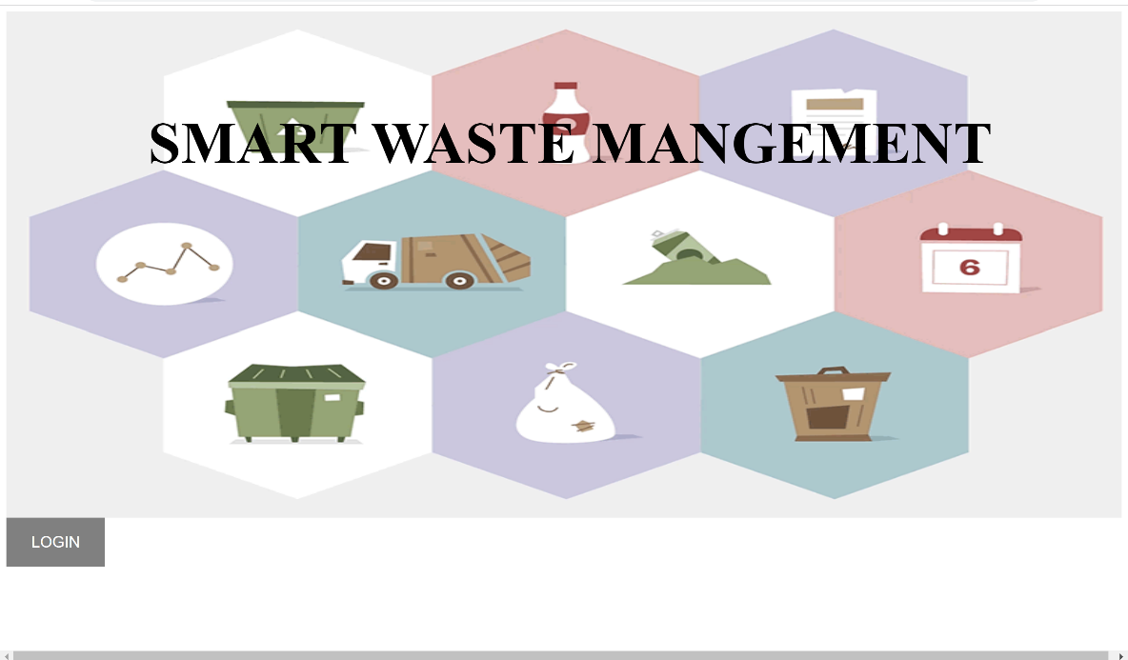

**2.**

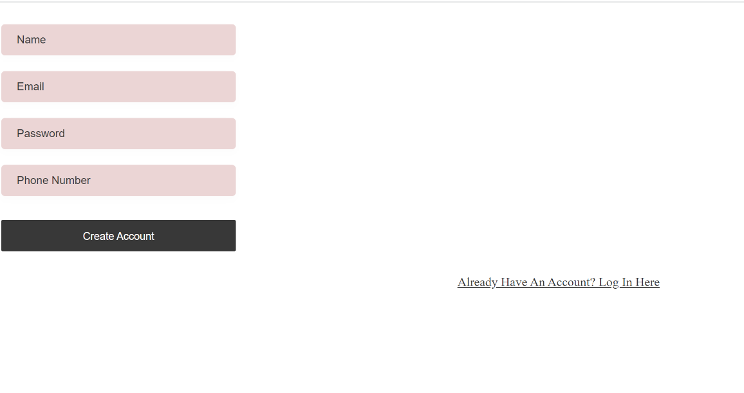

**3.**

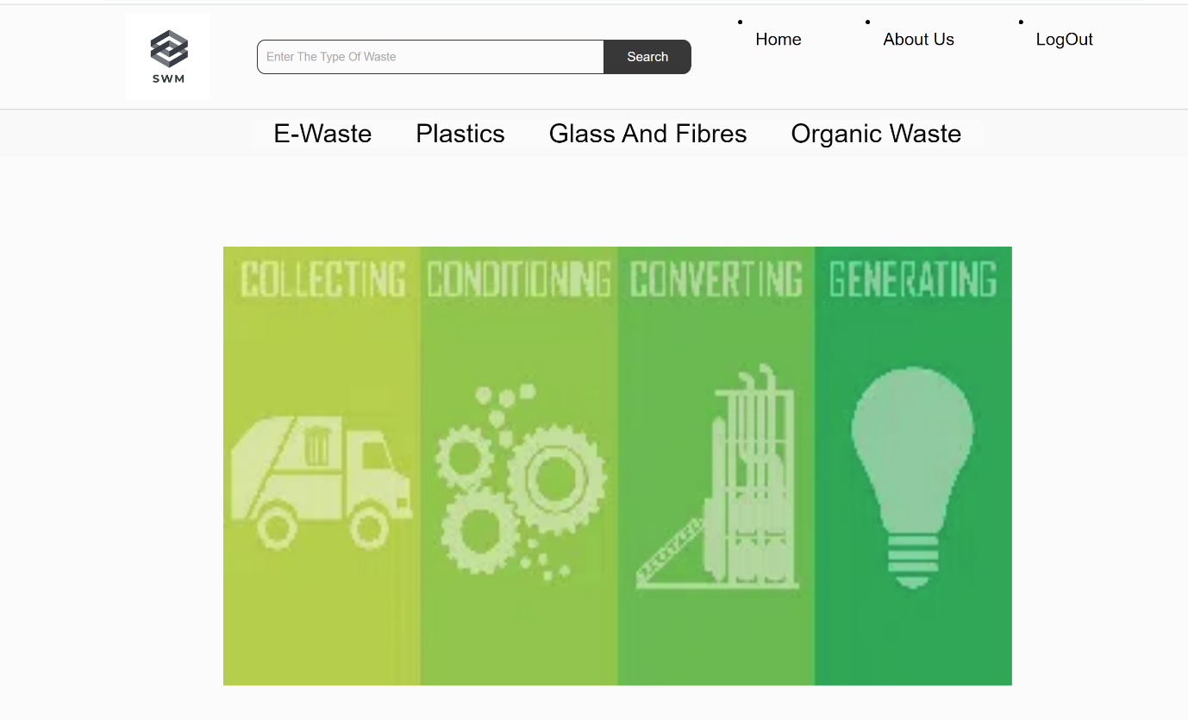

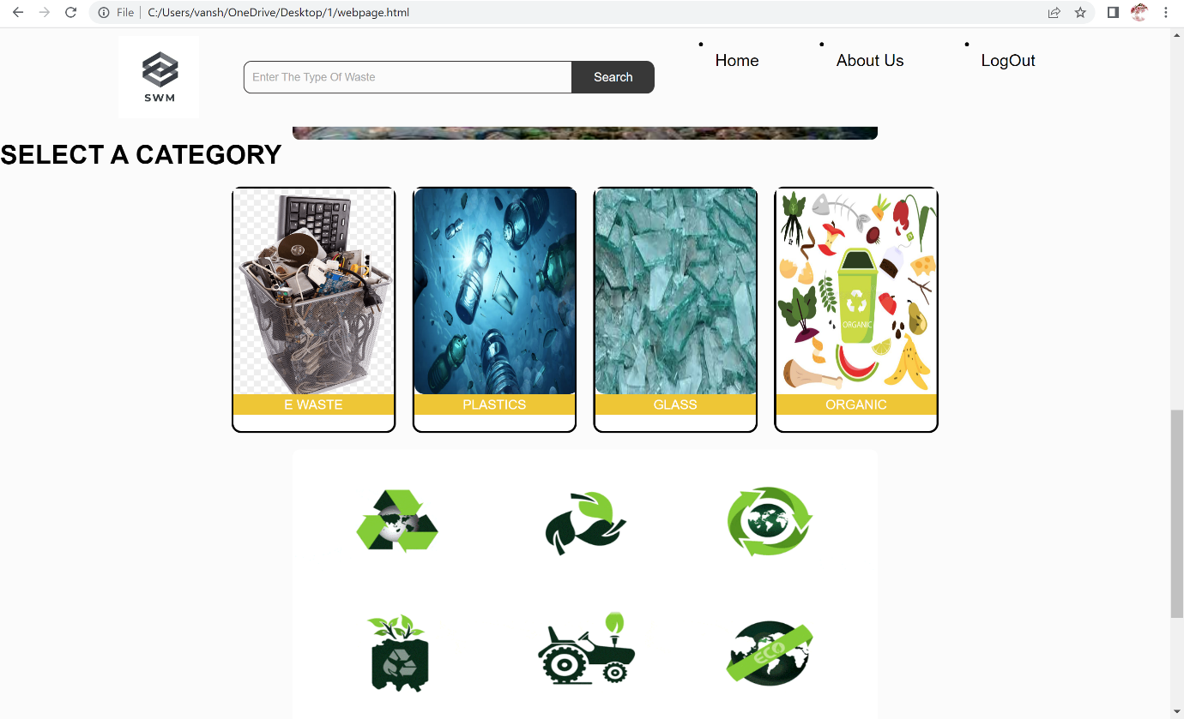

**5.** 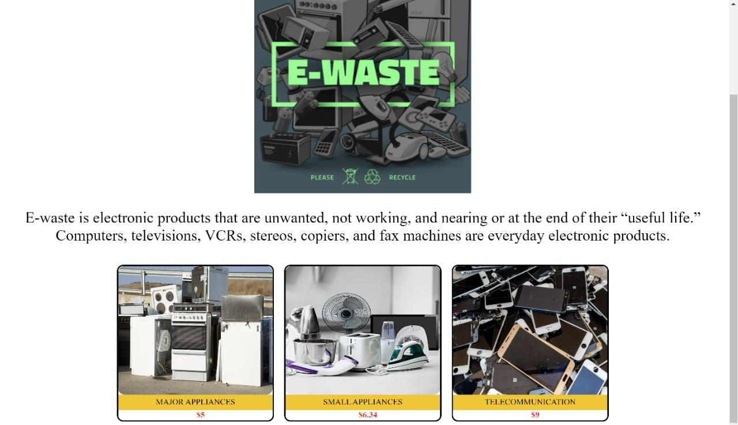

**6.**

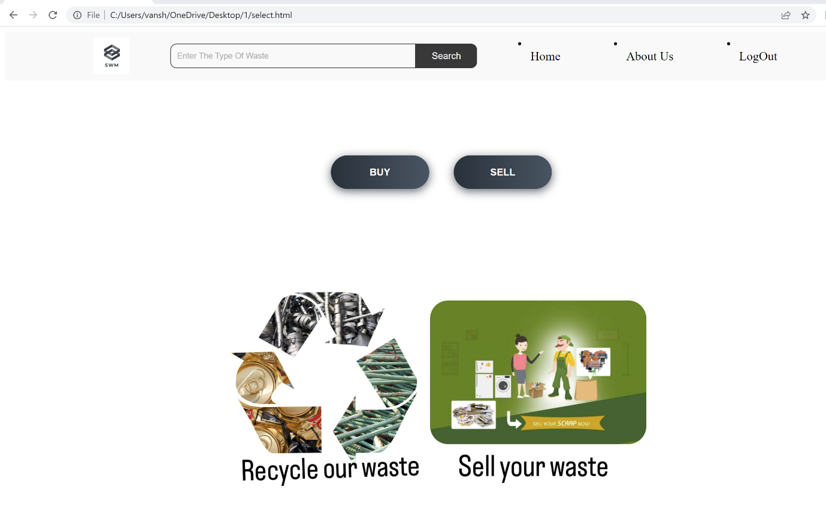

**7.**

**8.**

**LEARNING:**

Throughout the project implementation we explored many core technologies for building web pages and figured out real problem during the implementation .We figured out efficient ways to solve waste disposal and recycle to reduce the environmental and health hazards that arise from indiscriminate dumping of waste and pollution of natural resources like the land, sea, and air.

By learning HTML,CSS and JavaScript the code allowed us to implement Contribute to projects better, helps you understand and explore other languages and provides you with an opportunity to transition into a different career.

**CONCLUSION:**

We have successfully created a web application which reduces the complexity in managing the waste and also increases the interaction of public in managing the waste. In this website one can buy or sell the waste that can be recycled, thus the efficient disposal

of the waste starts at the ground level. Waste will be separated based on their type and recycling ability, so the person can categorize the waste at the very first level .The client who wants a particular kind of waste can find the availability and can purchase it. Here through selling and buying the waste through our website made managing the waste easier and increased the efficiency when compared with the regular methods of waste management, where the interaction of

the public was very less at the first level.